Guided LAB - 303.1.2A - How to Run Java Programs on Eclipse

Objective:
In this lab, we will demonstrate — step-by-step — how to run a Java program in Eclipse.

Learning Objective:
By the end of this lab, learners will be able to Run Java on Eclipse IDE.

Instructions:

For this lab, you must have Eclipse installed on your computer. Download Eclipse from https://www.eclipse.org/downloads/packages/.
Launch Eclipse by running "eclipse.exe" from the Eclipse installation directory.

Running a Java Program
Step 1: On Eclipse, click on the File → New → Java Project.
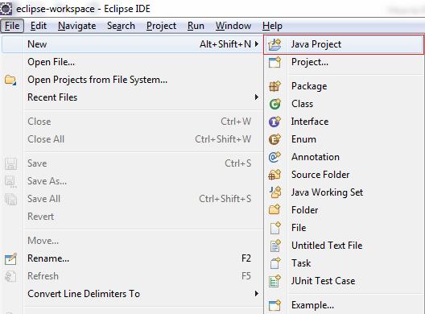

Step 2: Provide the Project Name and click on the Finish button.
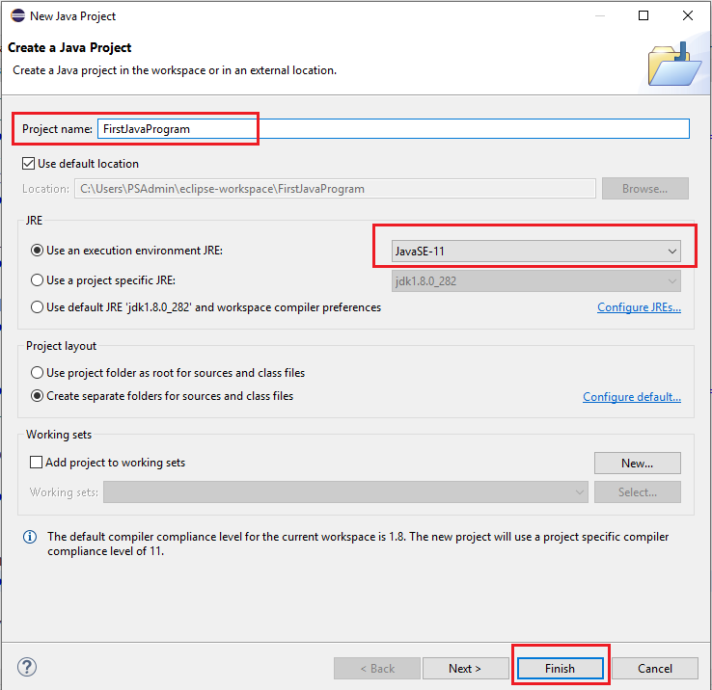

Step 3: In the Package Explorer (left-hand side of the window), select the project that you created.
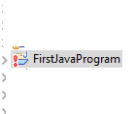
Step 4: Right-click on the Project name and select New > Class from the sub-menu. Provide the Class name and click on the Finish button.
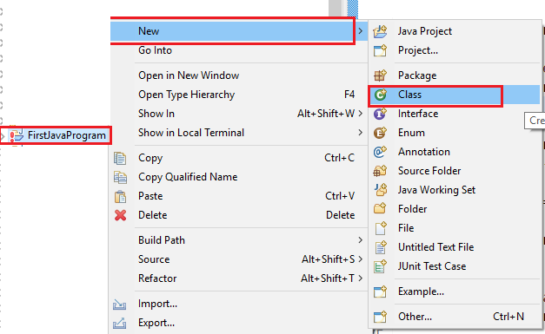

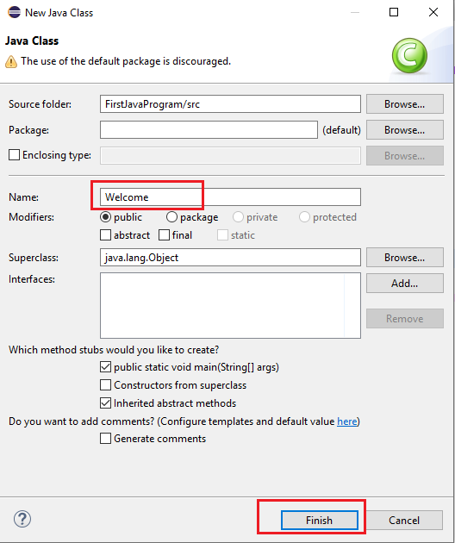
Step 5: Write the program as shown in the screenshot below and save it.

// This program prints Welcome to Java!

public class Welcome {
public static void main(String[] args) {
System.out.println("Welcome to Java!");
}
}

Step 6: Now, press Ctrl+F11 or click on the Run menu and select Run or click on the Run button.
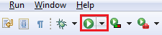
Step 7: Output
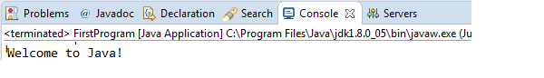

Reference: https://www3.ntu.edu.sg/home/ehchua/programming/howto/eclipsejava_howto.html\

Submission Instructions:
Include the following deliverables in your submission -
  - Submit your screenshot using the Start Assignment button in the top-right corner of the assignment page in Canvas.

CANVAS STAFF USE ONLY: Canvas Submission Guideline:
Instructions for Canvas Assignment Creation
Assignment Name: GLAB - 303.1.2- How to Run Java Program in Eclipse
Points: 100
Assignment Group: Module 303: Java SE Review (Not Graded)
Display Grade As: Complete/Incomplete
Do not count this assignment towards the final grade: Checked
Submission Types: File Uploads

Everything else is the default.

